INSTITUTE OF ENGINEERING & MANAGEMENT, KOLKATA

Department of Computer Science Engineering

Module 6 — Project Report

Smart Chassis Vibration Analysis System

Submitted by: Subhadeep Mondal
Enrolment Number: 12023002001213
Class Roll Number: B_43

Smart Chassis Vibration Analysis System
Complete Software Implementation, Dataset Processing, Errors and Solutions

- OBJECTIVE
The objective of this project is to develop a software-based Smart Chassis Vibration Analysis System that can analyze vehicle acceleration data to detect abnormal vibration patterns and identify potential chassis-related issues. The system processes automotive telematics data by selecting relevant acceleration channels, cleaning and preprocessing the signals, calculating vibration magnitude, and analyzing vibration behavior over time. It also performs timestamp analysis and resampling to prepare the data for further frequency-domain analysis using FFT. A threshold-based warning mechanism is implemented to indicate excessive vibration levels, demonstrating how vibration monitoring can support early detection of structural abnormalities and contribute to improved vehicle safety.

- DATASET
The Kaggle Automobile Telematics Dataset was downloaded as a ZIP archive and uploaded to Google Colab for analysis. After extraction and loading, the main dataframe contained 173,853 rows and included fields such as deviceId, timestamp, value, variable, and alarmClass. Among the 52 available sensor variables, ACCELERATION X, ACCELERATION Y, and ACCELERATION Z were selected for vibration analysis. During setup, a file-reading error occurred because the ZIP archive was incorrectly treated as a CSV. This was resolved by properly extracting the archive first and then loading the extracted CSV file using the correct file path and reading method.
Column | Purpose in analysis
deviceId | Vehicle/device identifier
timeMili | Millisecond time field; many values were missing
timestamp | Date/time field used for time-series processing
value | Sensor measurement value; converted to numeric
variable | Sensor-variable name used to select acceleration channels
alarmClass | Available alarm-class field in the original dataset

- DATA PREPROCESSING
3.2 Data Inspection
After the loading problem was solved, the dataframe was inspected. The variable column was examined to identify usable acceleration signals. The project selected the X, Y and Z acceleration variables because the project concept is based on vibration/acceleration measurements.
The timeMili field contained many missing values, so the timestamp field was used for time-series ordering and analysis.
3.2 Data Cleaning and Transformation
The three acceleration variables were filtered from the original dataframe. The sensor value field was converted to numeric using invalid-value coercion, invalid records were removed, and the data was pivoted so that each timestamp/device combination contained acceleration X, Y and Z in separate columns.
The resulting columns were renamed to accel_x, accel_y, and accel_z. Rows missing any of these three values were removed. The final cleaned acceleration dataframe contained 3,342 complete observations.
Core transformation:
acceleration = df[df["variable"].isin(["ACCELERATION X","ACCELERATION Y","ACCELERATION Z"])] acceleration["value"] = pd.to_numeric(acceleration["value"], errors="coerce")
The three channels were then pivoted by variable and renamed to the three acceleration columns.

- ABNORMAL VIBRATION DETECTTION
Metric | Value
Complete acceleration observations | 3,342
Mean vibration magnitude | 9.6449
Maximum vibration magnitude | 21.6280
Threshold | 13.9093
Normal observations | 3,296
Abnormal observations | 46
Abnormal percentage | 1.38%

- TIMESTAMP INVESTIGATION AND FREQUENCY ANALYSIS
The timestamp differences were inspected before applying FFT. Most observations were separated by approximately 5 seconds, but other intervals such as 10, 2, 6, 3, 7, 15 and 60 seconds were also present. The median interval was 5 seconds, while the maximum gap was 228,867 seconds. This confirmed that the original series was irregularly sampled.
Because a standard FFT assumes a regular sampling interval, the complete irregular series was not directly treated as a uniformly sampled signal. The vibration signal was resampled to 5-second intervals and short missing sections were interpolated before FFT preparation.
At a 5-second sampling interval, the sampling frequency is 0.2 Hz and the Nyquist frequency is 0.1 Hz. Therefore, this dataset cannot demonstrate high-frequency mechanical chassis vibration. The FFT section is appropriately presented as a low-frequency analysis demonstration.

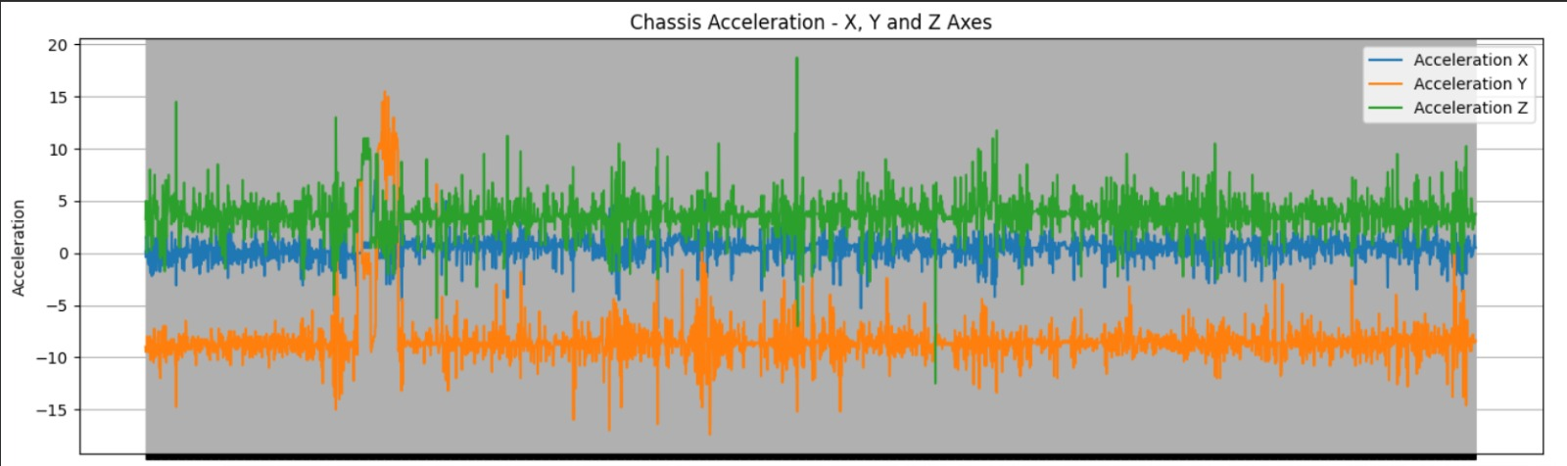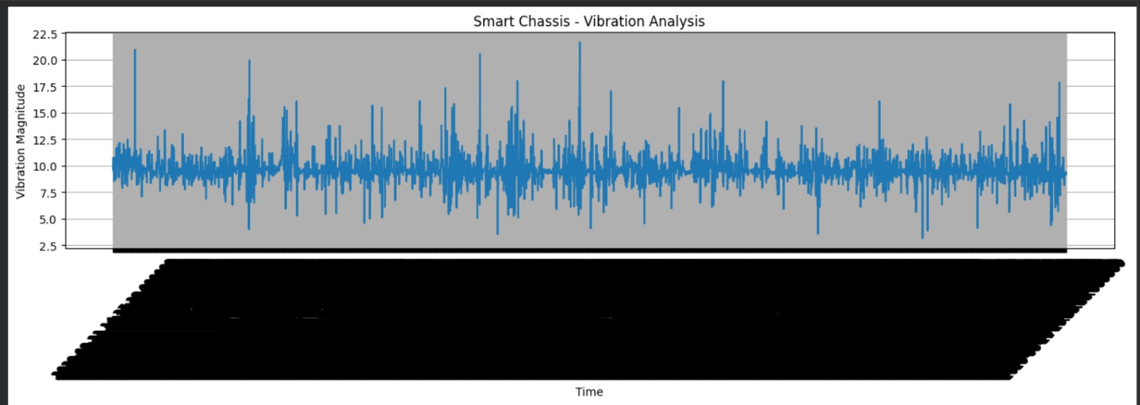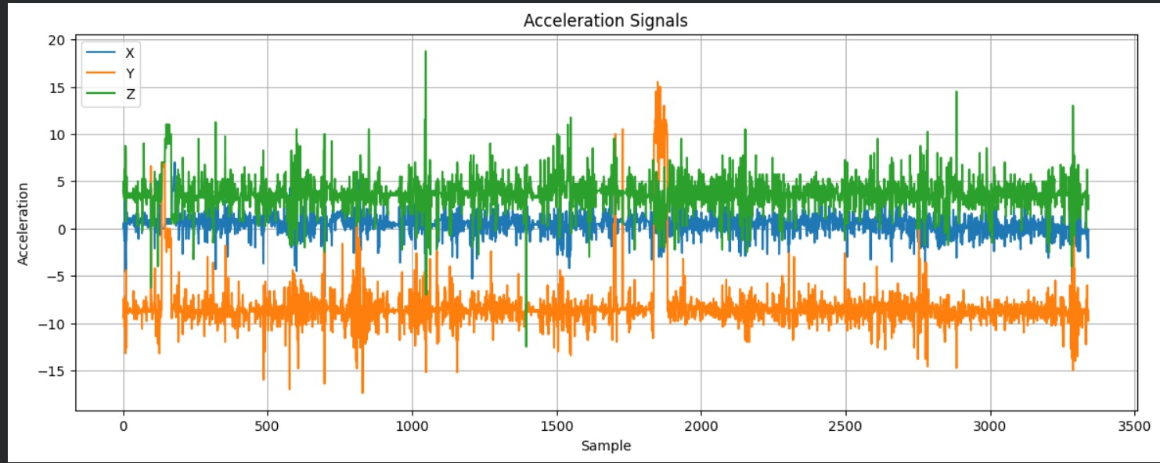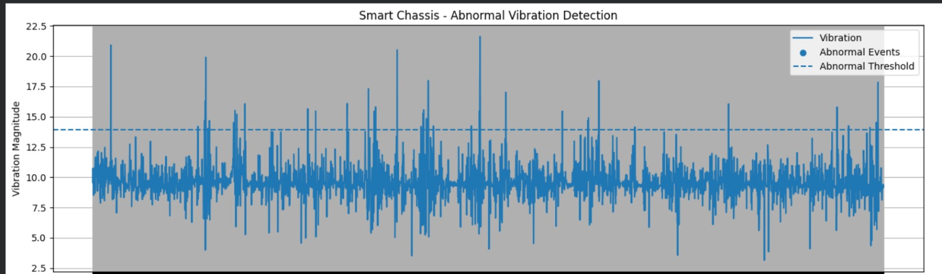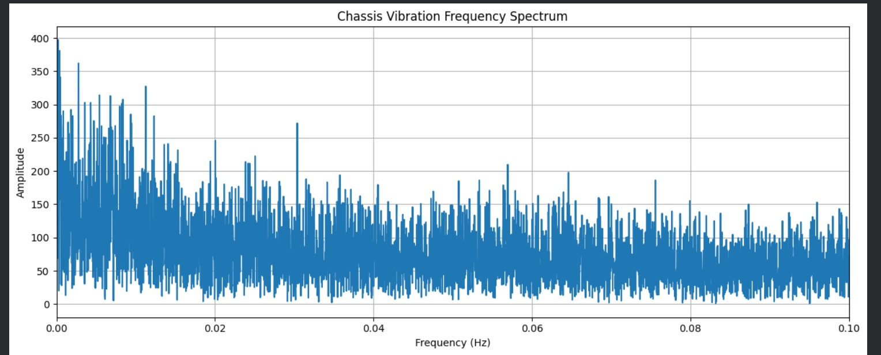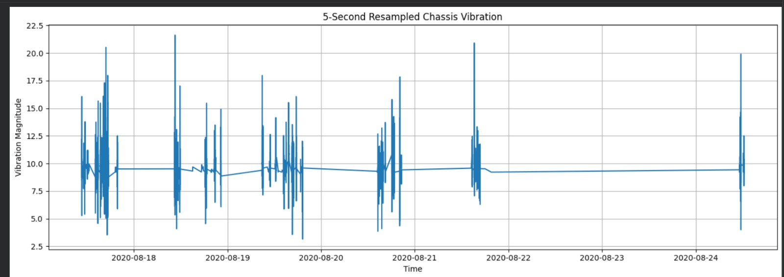

- CONCLUSION
The Smart Chassis Vibration Analysis System was successfully developed as a software prototype, overcoming challenges related to file handling, missing and non-numeric data, file paths, and irregular timestamps. After preprocessing, 3,342 complete three-axis acceleration observations were analyzed, with 46 abnormal observations identified using a threshold of 13.9093. The system demonstrates how vehicle vibration data can be processed to detect abnormal patterns and generate warning classifications, while actual prediction of structural damage would require higher-frequency sensor data and properly labeled fault conditions.

